How to run LLM

1. Open LM Studio
2. Select **meta-llama-3-8b-instruct** model
3. Make sure is ready and status running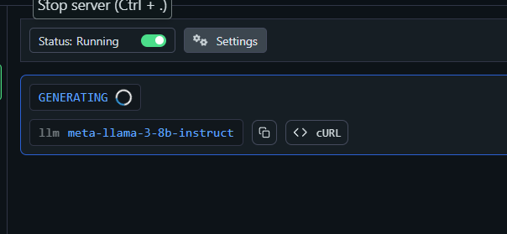
4. In Visual Studio set the environment
5. 1. python -m venv venv
6. 2. venv\Scripts\activate
7. 3. pip install openai flask scikit-learn pandas

5. test if scrip is running python main.py

6. Run Your Flask Server python gh_server.py

NOTE: you need an openai api key